题目1.输出99表格

截图：

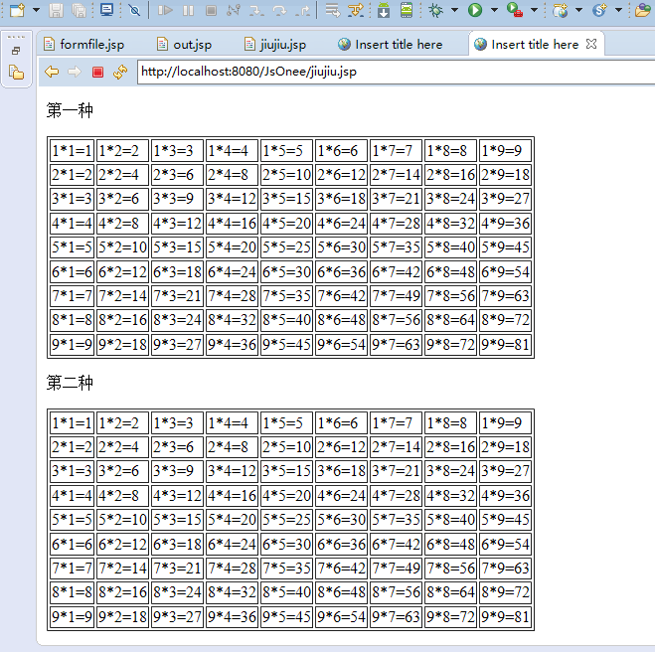

代码：

<%@ page language=*"java"* contentType=*"text/html; charset=UTF-8"*

pageEncoding=*"UTF-8"*%>

<!DOCTYPE html PUBLIC "-//W3C//DTD HTML 4.01 Transitional//EN" "http://www.w3.org/TR/html4/loose.dtd">

<html>

<head>

<meta http-equiv=*"Content-Type"* content=*"text/html; charset=UTF-8"*>

<title>Insert title here</title>

</head>

<body>

<p> 第一种 </p>

<%

out.println("<table border='1'");

**for**(**int** i = 1; i < 10; i++){

out.println("<tr>");

**for**(**int** j = 1; j < 10; j++){

out.println("<td>"+i+"*"+j+"="+(i * j)+"</td>");

}

out.println("</tr>");

}

out.println("</table>");

%>

<p>第二种</p>

<table border=*"1"*>

<%

**for**(**int** i = 1; i < 10; i++){

%>

<tr>

<%

**for**(**int** j = 1; j < 10; j++){

%>

<td><%=i %>*<%=j %>=<%=i*j %></td>

<%

}

%>

</tr>

<%

}

%>

</table>

</body>

</html>

题目2.输出由表单传输过来的行列

截图：

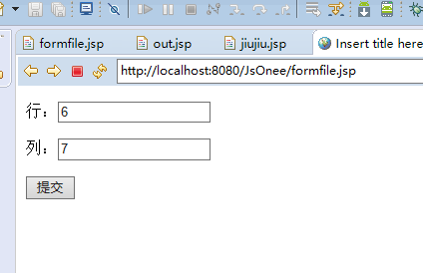

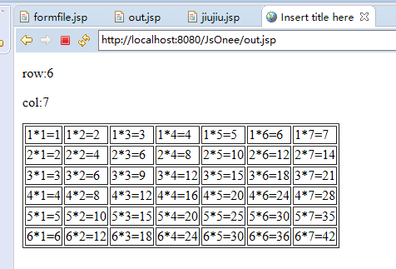

代码：

Formfile.jsp文件

<%@ page language=*"java"* contentType=*"text/html; charset=UTF-8"*

pageEncoding=*"UTF-8"*%>

<!DOCTYPE html PUBLIC "-//W3C//DTD HTML 4.01 Transitional//EN" "http://www.w3.org/TR/html4/loose.dtd">

<html>

<head>

<meta http-equiv=*"Content-Type"* content=*"text/html; charset=UTF-8"*>

<title>Insert title here</title>

</head>

<body>

<form action=*"out.jsp"* method=*"post"*>

<p>行：<input type=*"text"* name=*"row"*/></p>

<p>列：<input type=*"text"* name=*"col"*/></p>

<input type=*"submit"* value=*"提交"*/>

</form>

</body>

</html>

out.jsp文件

<%@ page language=*"java"* contentType=*"text/html; charset=ISO-8859-1"*

pageEncoding=*"ISO-8859-1"*%>

<!DOCTYPE html PUBLIC "-//W3C//DTD HTML 4.01 Transitional//EN" "http://www.w3.org/TR/html4/loose.dtd">

<html>

<head>

<meta http-equiv=*"Content-Type"* content=*"text/html; charset=ISO-8859-1"*>

<title>Insert title here</title>

</head>

<body>

<%

**int** row = Integer.valueOf(request.getParameter("row"));

**int** col = Integer.valueOf(request.getParameter("col"));

%>

<p>row:<%=row %></p>

<p>col:<%=col %></p>

<table border=*"1"*>

<%

**for**(**int** i = 1; i <= row; i++){

%>

<tr>

<%

**for**(**int** j = 1; j <= col; j++){

%>

<td><%=i %>*<%=j %>=<%=i*j %></td>

<%

}

%>

</tr>

<%

}

%>

</table>

</body>

</html>